Gig Services Recommendation Method for Fuzzy Requirement Description (TBD)
Subtitle as needed

Authors Name/s per 1st Affiliation (Author)
line 1 (of Affiliation): dept. name of organization
line 2: name of organization, acronyms acceptable
line 3: City, Country
line 4: e-mail: name@xyz.com
Authors Name/s per 2nd Affiliation (Author)
line 1 (of Affiliation): dept. name of organization
line 2: name of organization, acronyms acceptable
line 3: City, Country
line 4: e-mail: name@xyz.com

Abstract—This electronic document is a “live” template. The various components of your paper [title, text, heads, etc.] are already defined on the style sheet, as illustrated by the portions given in this document. DO NOT USE SPECIAL CHARACTERS, SYMBOLS, OR MATH IN YOUR TITLE OR ABSTRACT. (Abstract)
Keywords-component; formatting; style; styling; insert (key words)

Introduction (Heading 1)
All manuscripts must be in English. These guidelines include complete descriptions of the fonts, spacing, and related information for producing your proceedings manuscripts. Please follow them and if you have any questions, direct them to the production editor in charge of your proceedings at Conference Publishing Services (CPS): Phone +1 (714) 821-8380 or Fax +1 (714) 761-1784.
This template provides authors with most of the formatting specifications needed for preparing electronic versions of their papers. All standard paper components have been specified for three reasons: (1) ease of use when formatting individual papers, (2) automatic compliance to electronic requirements that facilitate the concurrent or later production of electronic products, and (3) conformity of style throughout a conference proceedings. Margins, column widths, line spacing, and type styles are built-in; examples of the type styles are provided throughout this document and are identified in italic type, within parentheses, following the example. PLEASE DO NOT RE-ADJUST THESE MARGINS. Some components, such as multi-leveled equations, graphics, and tables are not prescribed, although the various table text styles are provided. The formatter will need to create these components, incorporating the applicable criteria that follow.

Overview

需求图谱的构建：
随着大数据时代的发展，数据的增长已经成了爆炸性的趋势，图谱的推出极大的满足了用户的查询需求。本文以Fiverr网站为背景构建了网站的需求图谱，集成了图谱内各个节点的属性特征，为用户推荐Top-k个查询结果，旨在改善用户需求查询的满意度。
需求图谱是一种基于有向图的数据结构，由节点、边和语义信息组成。需求图谱相当于一个多源知识图谱的结合，由于本文图谱中涉及了服务的供求双方以及更多的信息，它不限于一个单一的知识图谱，也不只是一个简单的交易图谱。
本文定义的供求图谱为G，图谱以三元组的形式表达如下：
其中：
- VG为知识图谱中的顶点集合
- EG是知识图谱中的边的集合
- LE是边标签集

实体定义：
图谱中的实体就是构建的图结构的节点，是指从我们的数据集中选择出有意义的实体信息。实体的抽取对后续的信息获取以及需求描述的影响极大，是最基础也是最关键的部分。本文选取的实体既包含了Sellers等主要实体，也包含了各种属性特征实体。
1.主要实体定义：
Sellers：sellers代表Fiverr网站中服务的提供者。在Fiverr网站中，服务提供者seller会将自己的能力标价进行出售，吸引有需要的买家来购买，底价为5美元。
Gigs的其他属性：

Attribute | Example
服务收到的点赞量 | 1000
服务的关键字 | Java，website，Php
服务的创建时长 | 2010-10-01
服务的交付周期 | 3 days
服务的最低价格  服务的最高价格  服务所属的根目录  服务所属的子目录 | 5$  100$  Programming&tech  Wordpress service
在这些属性中,服务的点赞量表示了该服务的受欢迎程度,服务的关键字对服务内容的推荐有重要作用,服务的创建时长是服务存在的时间,服务的交付周期是买家看重的指标之一

Sellers属性实体：
用户的销售效率指标：计算公式如下
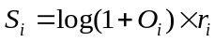

其中,ri的值为Oi /Di. Oi代表用户销售的总量，Di代表用户注册Fiverr的时间
Sellers的其他属性：
Attribute | Example
Country | Chinese
Lanuage | Chinese & English
Education | Harbin Institute of Technology
Certification | Master
Fiverr-level | Level 2
Avg_resp_time | 24 hrs
语义标签定义:
依照不同节点的现实语义，我们为边上的标签赋予了语义的信息，以下是我们赋予的部分语义便签供读者理解：

实体1 | 关系 | 实体2
服务购买者 | 购买(buy) | 服务
服务提供者 | 提供(provide) | 服务
服务 | 属于(sub-belong) | 子目录
子目录 | 附属于(belong) | 根目录
服务提供者 | 说(speak) | 语言
服务提供者 | 位于(located in) | 国家
服务提供者 | 评为(level) | 级别

通过对实体之间连接边的语义描述，使得实体与实体之间的从属、需求等关系可以通过语义的形式表达出来，有助于我们研究其背后的需求情况。

子图匹配：

问题描述：
本文主要研究的问题是：
根据用户的需求描述，得出查询所需的关键字，转化为查询图Q，在需求图谱G上进行子图匹配，根据Nema匹配算法，计算图谱中不同节点之间的相似度，利用推理算法迭代的提高更合适的候选匹配的分值，最终按序返回给用户top-k个查询结果。

问题定义：
定义 1：图同构. 如果有从G的节点到G‘ 的节点的双射函数μ，对于G中每个<n1,n2,l>，G‘ 中都有<u(n1),u(n2),l>，则G和G‘ 边同构，记为G ~ G‘’．由于返回的子图可能有很多结构相似的结果，所以本文在边同构的基础上进行节点标签信息的同构。本文把边和节点的标签同构看成相似性实现,由于图结构之间的相似性范围可能从非常高到非常低，很难设定统一的相似阈值．因此，我们设定找到K个最相似的图结构。
定义 2： Top-K 查询. 给定数据图G和查询图Q，根据匹配代价找到Top-k结果。在本文的问题中，当用户输入一组查询服务的query时，我们首先根据用户的描述，提取出query中的语义信息，然后将query转化为子图结构。进而在图中对相同结构的子图进行搜索，然后对query中出现的文本信息与子图中节点的语义标签信息进行语义相似度的计算，返回Top-k个最相似的服务。
Target Graph. A target graph that represents all the entities, attributes and relationships of the fiverr can be defined as a labeled, directed graph G = (V, E, L), with the node set V, edge set E, and a label function L, where (1) each node u∈V represents an entity in the network, (2) each edge e∈E denotes the relationship between two entities, and (3) L is a function that assigns to each node u (or edge e) a label L(u) (or L(e)) from a finite alphabet. In our fiverr dataset (1) the node labels can represent the type or attributes of the entities, e.g., name, tags, etc. (2) the edge labels represent the relation type between its corresponding two entities, e.g., isA, releaseBy, etc.
Query Graph. A query graph Q = (V_{Q}, E_{Q}, L_{Q}) is a directed labeled graph, with a set of query nodes V_{Q}, a set of query edges E_{Q}, and a label function L_{Q}, which assigns to each query node v∈V_{Q} a label L_{Q}(v) from a finite alphabet. Normally a query graph is not big and aims to describe a certain service corresponding to consumer’s requirements.

LSH语义匹配：
由于在进行子图匹配的过程中需要计算出待匹配节点的相似度，而作为服务的主要描述信息，服务的主题将是匹配过程中非常关心的一个属性。要想刻画出用户需求输入与我们所构建知识图谱中的单个服务主题的相似度需要用到自然语言处理方面的知识，本文选取LSH作为计算主题相似度的算法。局部敏感哈希(Locality Sensitive Hashing，LSH)算法是一种衡量文本相似度的算法。局部敏感哈希是近似最近邻搜索算法中最流行的一种，它有坚实的理论依据并且在高维数据空间中表现优异。它的主要作用就是从海量的数据中挖掘出相似的数据，可以具体应用到文本相似度检测、网页搜索等领域。局部敏感哈希是相对的，并不能做到绝对，LSH能做到的就是保持最大可能的相似度。

GSR4R Method

数据集描述

数据集来源于Fiverr网站。由于Fiverr网站并没有提供API接口，所以实验利用爬虫获得了研究所需要的数据。数据包括FIverr网站的评论信息，服务提供者seller的具体信息以及服务gigs的具体信息等。数据集的主要内容如下：

Item | Count
Sellers | 4198
Gigs | 51613
Comments | 1263596
Buyers | 333512
Active Buyers | 114413（34%）
Normal Buyers | 219099（66%）
Orders | 587182

数据集中，seller代表服务的提供者，即在网站中售卖个人能力的卖家。Gigs代表服务，是Fiverr网站中用来描述服务的名词。Comments代表我们爬取的交易双方的交流内容，包含了买家对卖家的评价以及打分。Buyers代表购买服务的人群，其实Active Buyers代表多次购买服务的买家，即购买次数超过一次的用户群体。Normal Buyers代表的是普通的卖家。Orders是数据集爬取的的成交单数总量。本文将利用数据集中的信息，挖掘用户的购买行为习惯，为提出需求的用户推荐合适的服务。

详细信息介绍：
服务部分：
服务根类别以及名称，服务子类别以及名称。目前Fiverr网站中一共含有12个类别，包括下属子类别共110个。数据集中服务根类别划分及比重如图所示

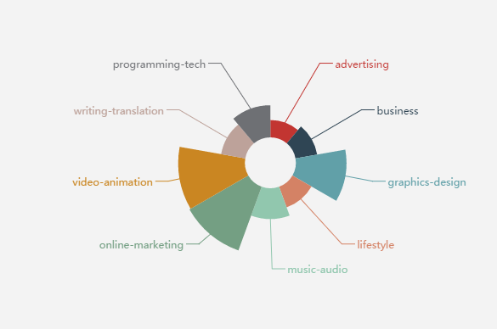
图4-1 Fiverr服务类别划分及比重图
服务指标部分
在表中我们统计了服务的平均分以及收到评分的次数，以及这个服务收到的点赞数，订单总数等。
服务属性部分
在具体属性表中，我们整合了服务的各种属性值。包括服务的标题内容，服务的认证状态，服务的交付周期，服务的价格以及最高价格。服务可接受的最大订单量等
用户属性部分
主要包含了用户的个人信息等，例如用户的国籍，受 教育程度，擅长技能等。
本文通过上述的几种方式对获取的非结构化数据进行建模，得到的结构化信息通过节点、边、或者是语义信息的形式体现出来。

构图
Considered our knowledge graph we have particular node types, edge types and different attributes which showed blow:
node types | category | seller | consumer | gig | comment
edge types | isA | releaseBy | belongTo
attributes | name | title | price | score | timespan | nationality | language | etc.
Table 1: Notations: Node Types, Edge Types and Attributes
为了存储整个知识图谱我们选择Neo4j作为数据库， Neo4j是一个高性能的NOSQL图形数据库，它将结构化数据存储在网络上而不是表中。Neo4j也可以被看作是一个高性能的图引擎，该引擎具有成熟数据库的所有特性。同时Neo4j具有很好的数据可视化支持，下图是经过Neo4j可视化后的网站知识图谱。
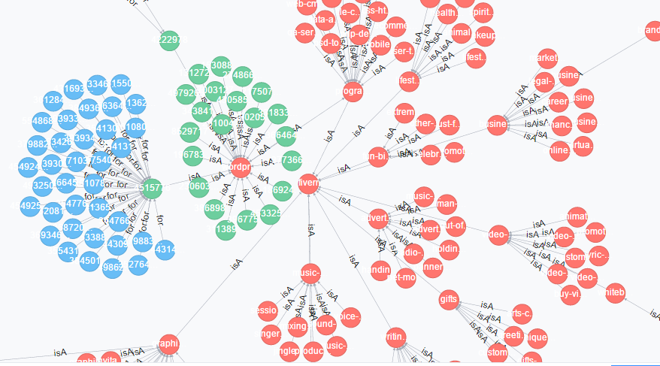
Figure 1: Target Graph
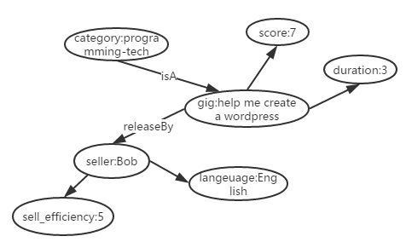
Figure 2: Query Graph
Figure 1&2 shows a part of target graph and a typical example of query graph. To build the whole target graph, we used Neo4j to store all the entities, edges and attributes also it can assist us to conveniently visualize the knowledge graph. As a query graph it’s structure can be either complicated or simple, there is no necessity to contain all the information in one graph whereas the requirements of consumer usually focus one or two certain area.

需求→查询子图
In order to precisely get consumers’ demands we adopt a Guided Requirement Completion method to automatically guess consumers’ potential requirements and give them instructions to complete it.
Firstly, we get a sentence from the consumer’s input which generally describes his/her desired service. After analysis of the existing data in the knowledge graph we find that every service entity has an attribute named title which can be roughly considered as the description of the service. So we employ LSH(Locality-Sensitive Hashing) method to cursorily calculate the semantic similarity between consumer’s input and each title of services in the target graph. Now the consumers’ ideal services can be extracted from the outputs of LSH, considered the output value indicates the similarity of corresponding titles the Top-N LSH scored services will be chosen as consumers’ possible selection.
Secondly, based on the possible selections all the attributes will be classified and for each attribute we can counted all the entities to generate a range of its value. By simply divide the attribute’s possible value into different scopes a relatively complete requirement will be generated based on the user’s options.
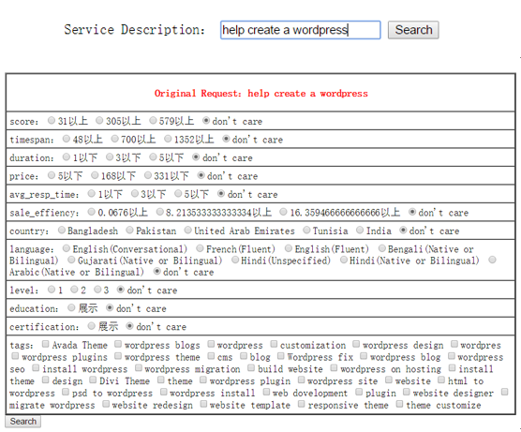
Figure 2: Requirement complete interface

查询子图→Top-N
Based on the complete requirement a query graph will be created. Then our key problem is how to get a proper subgraph of the query graph in the target graph. There are many algorithms to apply subgraph matching techniques such as BLINKS, SAGA, NESS, NeMa, etc. In this paper we choose NEMA as our fast subgraph matching algorithms, for (1) it proposes a novel subgraph matching cost metric that aggregates the costs of matching individual nodes, and unifies both structure and node label similarities. (2) based on the metric, NeMa formulate the minimum cost subgraph matching problem and propose a heuristic algorithm for solving the problem based on an inference model. (3) NeMa is both effective and efficient compared to the keyword search and various state-of-the-art graph querying techniques through lots of experiments.

Algorithm NeMa
Input: Target graph G(V, E, L), Query Graph Q(V_{Q}, E_{Q}, L_{Q}).
Output:Top-N Minimum cost matching of Q in G.
1. for each node v ∈ V_{Q} do compute M(v);
2. i := 0; flag := true;
3. Initiate iterative inferencing;
4. while flag do
5. i := i + 1;
6. for each v ∈ V_{Q} do
7. for each u ∈ M(v) do
8. compute Ui(v, u);
9. keep track of the current matches of neighbors v0 ∈ N(v);
10. compute optimal match Oi(v)
11. if more than a threshold number of query nodes v satisfy Oi(v) = Oi−1(v) then
12. flag := false;
13. construct Φ for all v ∈ V_{Q}
14. return Φ;
Figure 4: Iterative Inference Algorithm NeMa
Figure 4 shows the algorithm to generate Top-N matching results from target graph, by properly adjust the threshold we can control the number of N。

组合服务匹配
单个服务的匹配算法由上图可知。当用户的需求包含多个服务时，需要生成多个查询图来进行子图匹配。多个服务组合时会产生大量的组合服务，如何尽量减少组合服务的数量是我们所要研究的问题。
为了探究组合服务推荐的优先性，我们统计了有多次购买经验的顾客的数据。同时实验利用FP-growth算法，从一年内的用户购买服务的序列中挖掘得到了频繁出现的根目录，频繁出现的子目录，以及频繁出现的服务关键字序列。数据显示：人们的购买序列频次按根目录顺序依次为同一根目录，频繁根目录，不同根目录。在子目录的调查中，顺序为频繁子目录，同一子目录，不同子目录。
影响组合服务推荐的主要因素如下图所示：

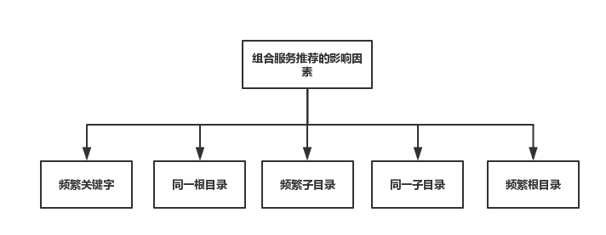

本文认为影响组合服务的推荐因素有上图五个因素。我们根据组合服务序列中关键字是否是频繁关键字，根目录序列是同一根目录还是频繁根目录，子目录序列是频繁子目录还是同一子目录来判别组合服务推荐的优先性。首先，关键字序列代表服务的主要内容是否符合推荐内容，是最重要的判别结果。其次，根据统计结果可知，组合服务序列常常属于同一根目录，所以要判别该序列是属于同一根目录还是属于频繁根目录，而在同一根目录下，频繁子目录和同一子目录的购买频次很明显的高于其他情况。文章将根据统计结果来规定组合服务推荐的优先性。
下表是我们统计出的组合服务序列可能存在的10种情况如下表，他们在实际情况中的分布如下图：

名称 | 1 | 2 | 3 | 4 | 5 | 6 | 7 | 8 | 9 | 10
频繁关键字 | √ | √ | √ | √ | √
同一根目录 | √ | √ | √ |  |  | √ | √ | √
同一子目录 | √ |  |  |  |  | √
频繁子目录 |  | √ |  |  |  |  | √
频繁根目录 |  |  |  | √ |  |  |  |  | √

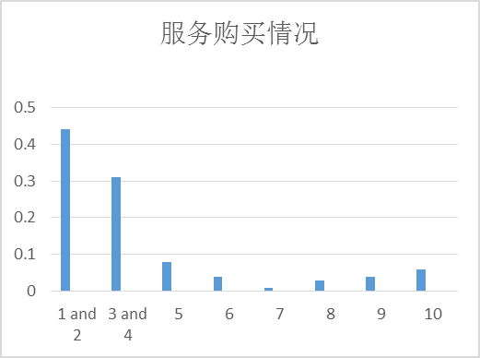
由统计结果显示可知，优先级1 和 2的服务购买频次几乎占到了整个购买情况比例的一半，故我们将1和2列为强相关的优先级。3 和4的购买频次仅次于1 和2 ，将他们设为相关的优先级，其余级别设为弱相关优先级。

Experiments
论文将现有的fiverr数据集划分为不同的数量级分别应用本文提出的方法进行实验，其中最大的数量级为5000条服务，最小的为1000条服务。实验的测试集为500条，分别以论文中提出的引导式搜索方法和直接在大图中进行搜索的方法进行对比，下图是两种方法在不同数量级下平均运行时间的增长趋势以及对比。
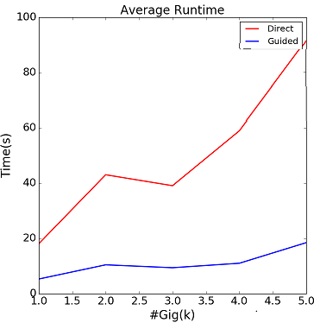
Figure 5: Average Runtime of Different Methods
从图中我们可以看出采用直接搜索的方式平均耗时过大且增长幅度也远高于引导式的搜索方法，因此我们所提出的方法在实际应用中是具有一定可行性的。
接下来实验就两种方法最终返回的平均Top-N数量进行了对比，并且还考量了引导式搜索方法在整个搜索空间中每次压缩比例的具体情况。
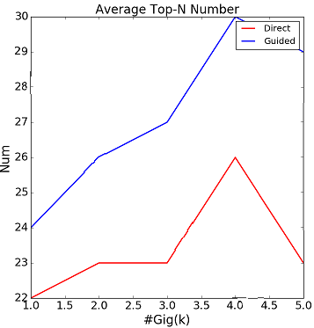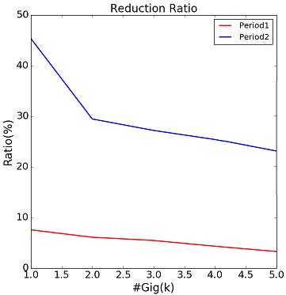
Figure 6: #Top-N & Reduction ratio of Different Methods
实验结果显示，采用引导式搜索方法返回的Top-N数量会随着实验数据集的增长而增加，而直接搜索返回的最终Top-N数量并没有随着数据集的增加产生明显的变化。同时，采用引导式的搜索方法在产生最终结果之前经过了两轮数据压缩，起到了很好的缓冲作用，也提高整个搜索过程的效率。
最后，我们还对比了以上两种方法在每个数量级下返回服务的最优占比情况，实验中主要统计了Top-3、Top-5、以及Top-10所包含的最优服务的平均值，具体数据在下表中展示:
表2：两种方法最优服务占比情况
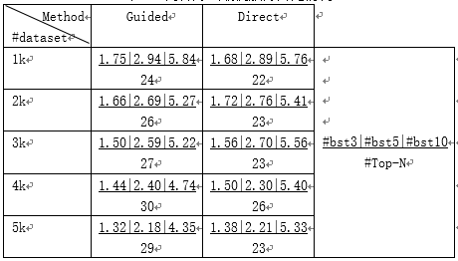
通过对实验结果的分析可以看出，论文提出的引导式搜索方法最终得到的最优服务占比与传统的直接搜索方法相比没有太大的差别，但是在搜索时间上得到了很大地提升。因此在提升效率的同时保证了算法的可信度。(#bst3:排名前3的服务中最优服务平均数量；#bst5:排名前5的服务中最优服务平均数量；#bst0:排名前10的服务中最优服务平均数量；#Top-N:方法返回的所有服务平均数量)

实验环境：
实验采用Java，Python两种语言进行了程序的编写。
实验采用的测试集中包含了服务规模不同（10000-50000）的5个测试集，每个测试集都对应一个包含250个用户需求的候选集。

评价标准：
实验主要考虑的内容是：推荐服务结果中的相关性衡量占比。通过比较根据用户需求得到的服务候选集中强相关，相关和弱相关占有的比例，预测推介服务结果的准确性。相关性衡量公式表示如下：
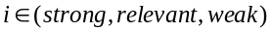

其中，i代表推荐结果与服务需求描述的相关性类别，i可以为强相关，相关或者弱相关。i类别的筛选条件在上文中已经提及。K代表的是为组合服务中每个服务推荐的Top-K的服务结果中的k。n代表组合服务中涉及到组合的服务个数.K^{n}代表多种服务可能的组合数目。S_{i} 代表属于i类相关的服务组合。

相关性衡量对比试验：
为了验证组合服务的查询结果以及相关性，本文在不同服务规模下验证了250个组合服务需求的相关性，以Top-5 为先验条件查询时，验证结果如下：
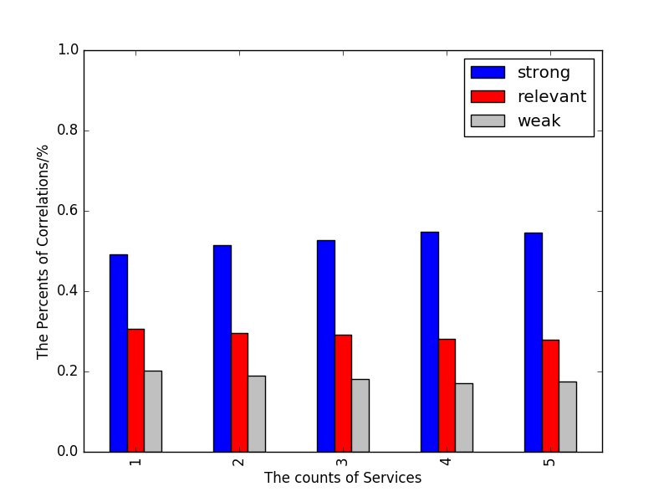

横轴代表服务的规模，分别是10000-50000个服务，纵轴代表不同相关类别所占的比例。从图中可以看到，随着服务的增加，强相关的占比有所增大。综合实验的查询结果可知：约81%的结果是相关或者强相关的（其中强相关占58%左右），约有19%的结果是弱相关的。
为了更直观的显示推荐的结果，文章以50个用户需求为例，展示了每个用户需求的相关性衡量的具体推荐结果。图表展示如下：
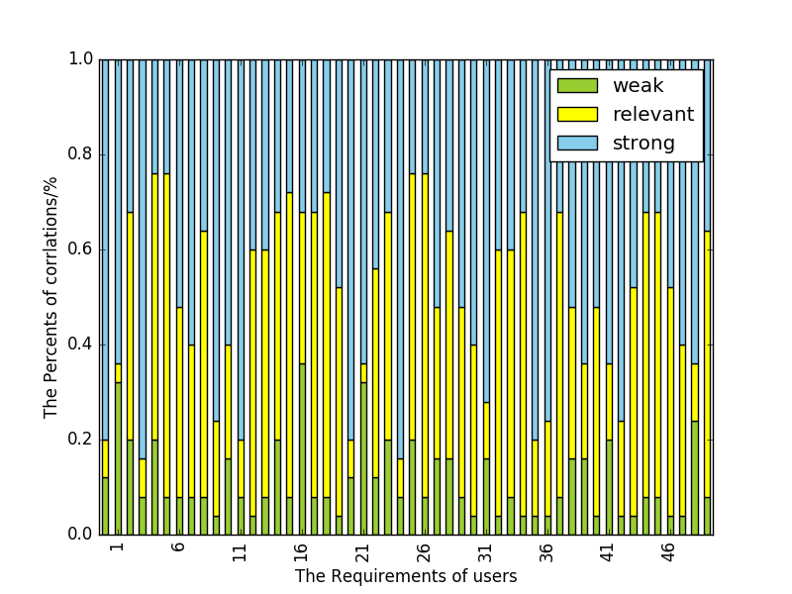

Case Study(如果有的话)
单个服务例子：

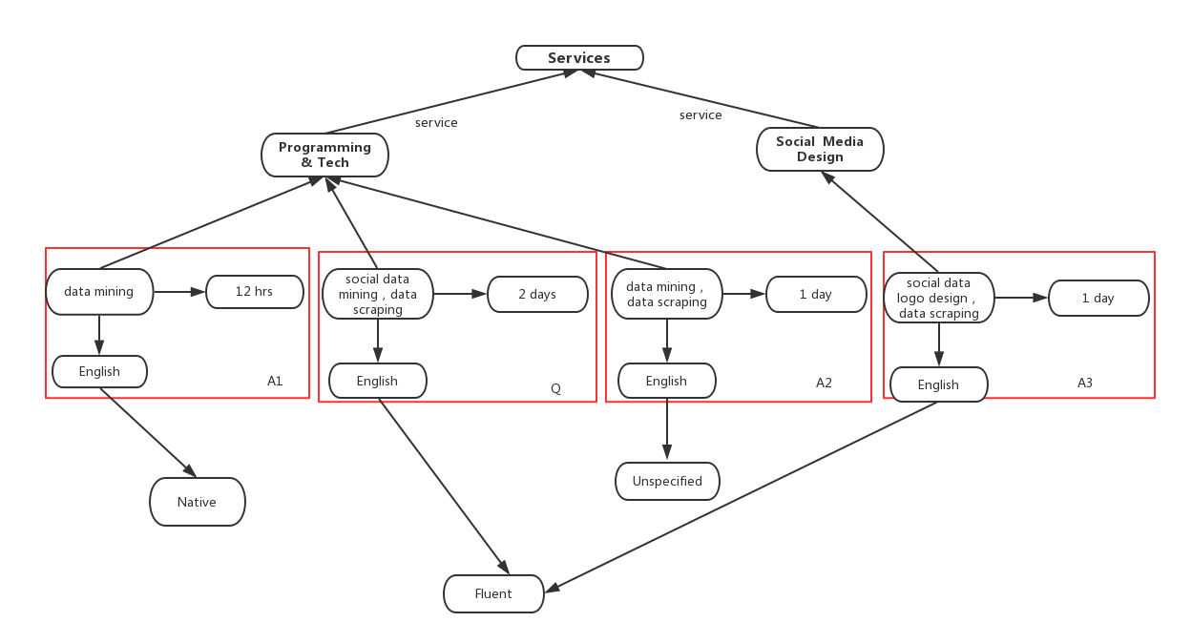

上图我们实验的例子展示：图中的Q是一个查询图：
Social data mining，data scraping － 2 days － English（fluent）
第一字段代表我们结构化用户的需求描述得到的服务的关键字，第二个字段代表用户希望卖家在2天内回复，第三个字段时用户对卖家的语言要求。A1，A2，A3是三个候选结果。从图中我们观察到，A3同A1 ，A2相比，它与查询图不在一个子目录中。在A1，A2比较中，A1中的服务提供者的英文能力更好，并且回复速度更快，更合适。

服务组合例子：
举例来说：用户的需求描述是：I want you to design a photo cartoon for me，and make a cool video with the cartoon。从需求描述看，可以分析出用户提出了两个服务：服务A设计卡通肖像以及服务B制作一段小视频。那么组合服务候选集 {A1,A2,A3…} 和候选集 { B1,B2,B3…} 就是实验要探究的问题。以组合服务(A1,B1)为例，若服务 A1,B1的组合关键字序列为频繁关键字序列，并且组合服务(A1，B1)属于同一根目录且为频繁子目录，那么其服务组合的优先级为最高，优先推荐该组合服务。其余组合按照优先级列表依次排列。

Related Work
After the text edit has been completed, the paper is ready for the template. Duplicate the template file by using the Save As command, and use the naming convention prescribed by your conference for the name of your paper. In this newly created file, highlight all of the contents and import your prepared text file. You are now ready to style your paper.

Authors and Affiliations
The template is designed so that author affiliations are not repeated each time for multiple authors of the same affiliation. Please keep your affiliations as succinct as possible (for example, do not differentiate among departments of the same organization). This template was designed for two affiliations.

For author/s of only one affiliation (Heading 3): To change the default, adjust the template as follows.

Selection (Heading 4): Highlight all author and affiliation lines.

Change number of columns: Select Format >
Columns >Presets > One Column.

Deletion: Delete the author and affiliation lines for the second affiliation.

For author/s of more than two affiliations: To change the default, adjust the template as follows.

Selection: Highlight all author and affiliation lines.

Change number of columns: Select Format >
Columns > Presets > One Column.

Highlight author and affiliation lines of affiliation 1 and copy this selection.

Formatting: Insert one hard return immediately after the last character of the last affiliation line. Then paste the copy of affiliation 1. Repeat as necessary for each additional affiliation.

Reassign number of columns: Place your cursor to the right of the last character of the last affiliation line of an even numbered affiliation (e.g., if there are five affiliations, place your cursor at end of fourth affiliation). Drag the cursor up to highlight all of the above author and affiliation lines. Go to Format > Columns and select “2 Columns”. If you have an odd number of affiliations, the final affiliation will be centered on the page; all previous will be in two columns.

Identify the Headings
Headings, or heads, are organizational devices that guide the reader through your paper. There are two types: component heads and text heads.
Component heads identify the different components of your paper and are not topically subordinate to each other. Examples include Acknowledgments and References and, for these, the correct style to use is “Heading 5”. Use “figure caption” for your Figure captions, and “table head” for your table title. Run-in heads, such as “Abstract”, will require you to apply a style (in this case, italic) in addition to the style provided by the drop down menu to differentiate the head from the text.
Text heads organize the topics on a relational, hierarchical basis. For example, the paper title is the primary text head because all subsequent material relates and elaborates on this one topic. If there are two or more sub-topics, the next level head (uppercase Roman numerals) should be used and, conversely, if there are not at least two sub-topics, then no subheads should be introduced. Styles named “Heading 1”, “Heading 2”, “Heading 3”, and “Heading 4” are prescribed.

Figures and Tables

Positioning Figures and Tables: Place figures and tables at the top and bottom of columns. Avoid placing them in the middle of columns. Large figures and tables may span across both columns. Figure captions should be below the figures; table heads should appear above the tables. Insert figures and tables after they are cited in the text. Use the abbreviation “Fig. 1”, even at the beginning of a sentence.
- Table Type Styles
Table Head | Table Column Head
Table Head | Table column subhead | Subhead | Subhead
copy | More table copyª
a. Sample of a Table footnote. (Table footnote)
We suggest that you use a text box to insert a graphic (ideally 300 dpi), with all fonts embedded) because, in an MSW document, this method is somewhat more stable than directly inserting a picture.
To have non-visible rules on your frame, use the MSWord pull-down menu, select Format > Borders and Shading > Select “None”.
- Example of a ONE-COLUMN figure caption.
Please see last page of this document for AN EXAMPLE of a 2-COLUMN Figure.
Figure Labels: Use 8 point Times New Roman for Figure labels. Use words rather than symbols or abbreviations when writing Figure axis labels to avoid confusing the reader. As an example, write the quantity “Magnetization”, or “Magnetization, M”, not just “M”. If including units in the label, present them within parentheses. Do not label axes only with units. In the example, write “Magnetization (A/m)” or “Magnetization {A[m(1)]}”, not just “A/m”. Do not label axes with a ratio of quantities and units. For example, write “Temperature (K)”, not “Temperature/K”.

Footnotes
Use footnotes sparingly (or not at all) and place them at the bottom of the column on the page on which they are referenced. Use Times 8-point type, single-spaced. To help your readers, avoid using footnotes altogether and include necessary peripheral observations in the text (within parentheses, if you prefer, as in this sentence).

Conclusion
You must submit the IEEE Electronic Copyright Form (ECF) per Step 7 of the CPS author kit’s web page. THIS FORM MUST BE SUBMITTED IN ORDER TO PUBLISH YOUR PAPER.
Please see Step 9 for ordering reprints of your paper. Reprints may be ordered using the form provided as <reprint.doc> or <reprint.pdf>.

Acknowledgment
The preferred spelling of the word “acknowledgment” in America is without an “e” after the “g”. Avoid the stilted expression, “One of us (R.B.G.) thanks . . .” Instead, try
“R.B.G. thanks”. Put applicable sponsor acknowledgments here; DO NOT place them on the first page of your paper or as a footnote.

References
List and number all bibliographical references in 9-point Times, single-spaced, at the end of your paper. When referenced in the text, enclose the citation number in square brackets, for example [1]. Where appropriate, include the name(s) of editors of referenced books. The template will number citations consecutively within brackets [1]. The sentence punctuation follows the bracket [2]. Refer simply to the reference number, as in [3]—do not use “Ref. [3]” or “reference [3]” except at the beginning of a sentence: “Reference [3] was the first . . .”
Number footnotes separately in superscripts. Place the actual footnote at the bottom of the column in which it was cited. Do not put footnotes in the reference list. Use letters for table footnotes.
Unless there are six authors or more give all authors’ names; do not use “et al.”. Papers that have not been published, even if they have been submitted for publication, should be cited as “unpublished” [4]. Papers that have been accepted for publication should be cited as “in press” [5]. Capitalize only the first word in a paper title, except for proper nouns and element symbols.
For papers published in translation journals, please give the English citation first, followed by the original foreign-language citation [6].

- G. Eason, B. Noble, and I. N. Sneddon, “On certain integrals of Lipschitz-Hankel type involving products of Bessel functions,” Phil. Trans. Roy. Soc. London, vol. A247, pp. 529–551, April 1955. (references)
- J. Clerk Maxwell, A Treatise on Electricity and Magnetism, 3rd ed., vol. 2. Oxford: Clarendon, 1892, pp.68–73.
- I. S. Jacobs and C. P. Bean, “Fine particles, thin films and exchange anisotropy,” in Magnetism, vol. III, G. T. Rado and H. Suhl, Eds. New York: Academic, 1963, pp. 271–350.
- K. Elissa, “Title of paper if known,” unpublished.
- R. Nicole, “Title of paper with only first word capitalized,” J. Name Stand. Abbrev., in press.
- Y. Yorozu, M. Hirano, K. Oka, and Y. Tagawa, “Electron spectroscopy studies on magneto-optical media and plastic substrate interface,” IEEE Transl. J. Magn. Japan, vol. 2, pp. 740–741, August 1987 [Digests 9th Annual Conf. Magnetics Japan, p. 301, 1982].
- M. Young, The Technical Writer’s Handbook. Mill Valley, CA: University Science, 1989.
- Electronic Publication: Digital Object Identifiers (DOIs):
Article in a journal:
- D. Kornack and P. Rakic, “Cell Proliferation without Neurogenesis in Adult Primate Neocortex,” Science, vol. 294, Dec. 2001, pp. 2127-2130, doi:10.1126/science.1065467.
Article in a conference proceedings:
- H. Goto, Y. Hasegawa, and M. Tanaka, “Efficient Scheduling Focusing on the Duality of MPL Representatives,” Proc. IEEE Symp. Computational Intelligence in Scheduling (SCIS 07), IEEE Press, Dec. 2007, pp. 57-64, doi:10.1109/SCIS.2007.357670.

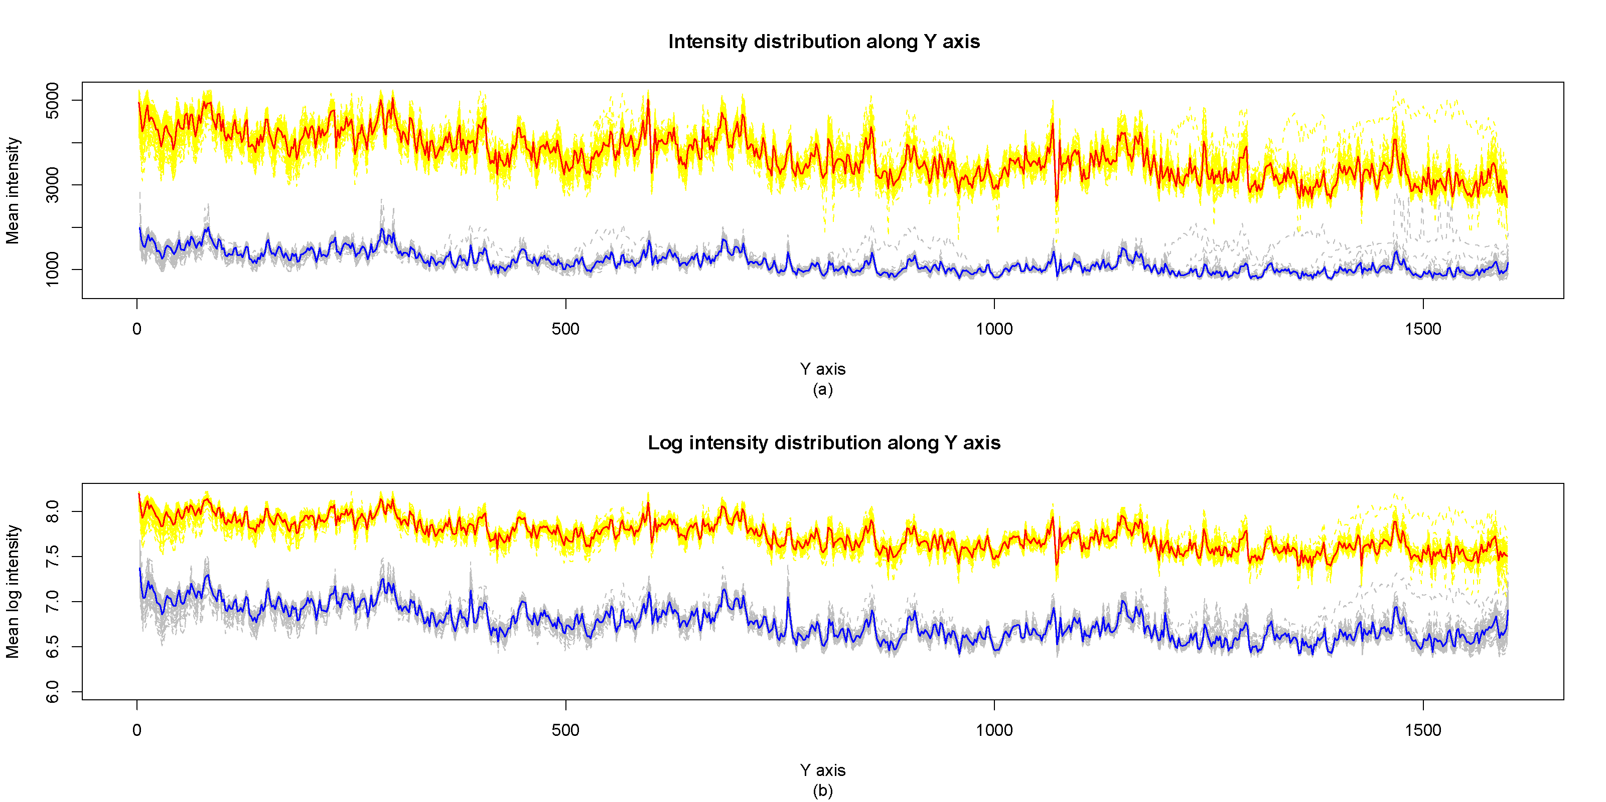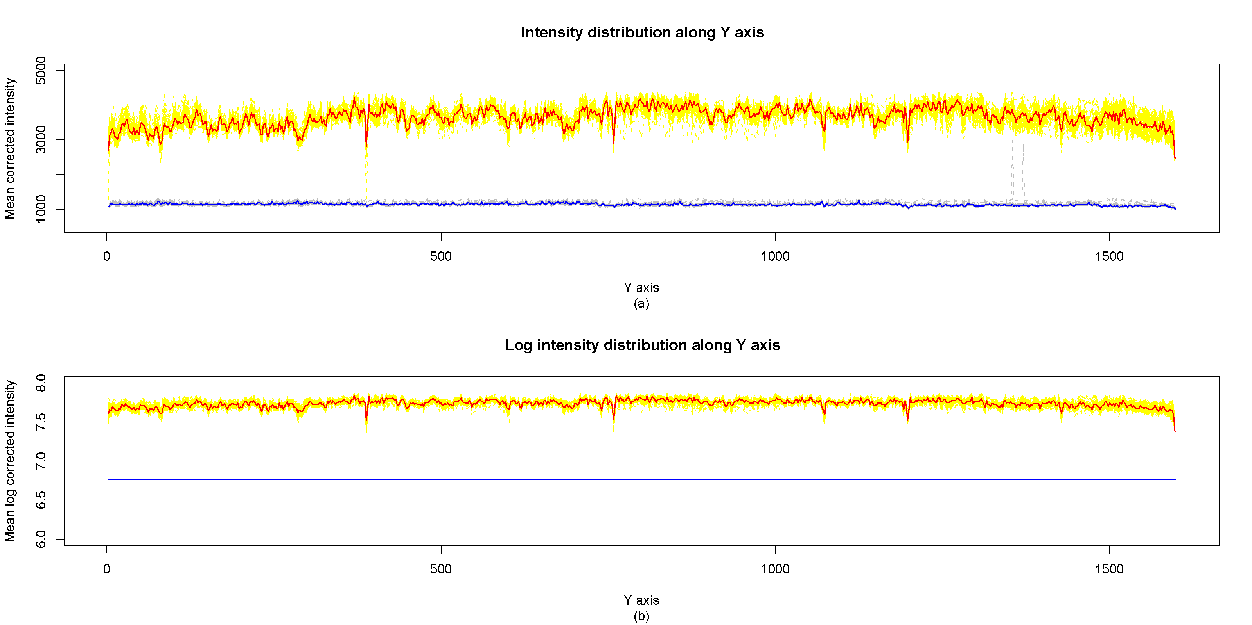
- Example of a TWO-COLUMN figure caption: (a) this is the format for referencing parts of a figure.

